Ideation Phase

Define the Problem Statements

|  |  |
| --- | --- |
| Date | 26 June 2025 |
| Team ID | LTVIP2025TMID53123 |
| Project Name | ResolveNow: Your Platform for Online  Complaints |
| Maximum Marks | 2 Marks |

**□ Customer Problem Statement – ResolveNow**

Customers today face a lack of efficient and transparent systems for registering and resolving complaints. After submitting an issue, they are often left without updates, have no direct channel to communicate with support agents, and experience significant delays in resolution. This creates frustration, erodes trust, and discourages users from engaging with complaint processes in the future.

Users need a simple, real-time, and interactive platform where they can easily file complaints, track their status, and communicate directly with agents. They expect timely updates, secure handling of their information, and a clear path to resolution—all in one place.

**ResolveNow** addresses this need by providing a centralized, user-friendly system that empowers customers with visibility, communication, and control over their complaints— creating a smoother and more satisfying experience.

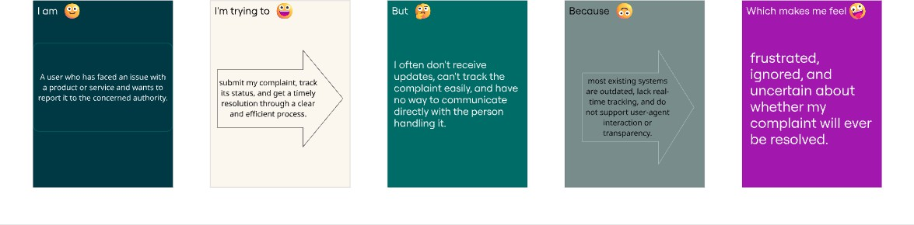

**□ Customer Problem Statement Table – ResolveNow**

|  |  |  |  |  |  |
| --- | --- | --- | --- | --- | --- |
| **Problem Statement (PS)** | **I am (Customer)** | **I'm trying to** | **But** | **Because** | **Which makes me feel** |
| **PS-1** | a customer with a product issue | submit a complaint and get it resolved | I don’t get any update | there's no real- time tracking | frustrated and ignored |

|  |  |  |  |  |  |
| --- | --- | --- | --- | --- | --- |
| **Problem Statement (PS)** | **I am (Customer)** | **I'm trying to** | **But** | **Because** | **Which makes me feel** |
| **PS-2** | a citizen reporting a civic issue | raise a complaint and see action taken | I can’t see any progress | the system lacks transparency | helpless and unheard |
| **PS-3** | a user of the platform | track my complaint status | I don’t know who is handling it | the system doesn’t show agent details | confused and anxious |
| **PS-4** | a customer with limited tech knowledge | file a complaint easily | I find the form too complex | it has too many technical fields | discouraged and lost |
| **PS-5** | a user with a complaint history | view all my previous complaints | there’s no organized history | complaints aren’t grouped or searchable | disorganized and annoyed |
| **PS-6** | a customer needing urgent help | get a quick response from the agent | I can’t message them directly | there’s no live chat or communication option | stuck and unsupported |
| **PS-7** | a non- English- speaking user | submit a complaint in my native language | the platform only supports English | there’s no multilingual feature | excluded and confused |
| **PS-8** | a user wanting to give feedback | rate the complaint resolution | there’s no feedback option | the system lacks a review feature | voiceless and unacknowledged |